SIT757

“Claytown”

RESEARCH REPORT

Unit title: Content Creation for Virtual Reality

Unit Chair: Alexander Baldwin

Author: Tong-Chang Wu (SID: 231288591)

Date submitted: 03/08/2018

Word count: 1167

Contents

Introduction 3

Background of Concept 3

Motivation 3

The prototype 3

Direction 4

Examples of Concept 4

Reference Material 5

Plan for Assets 6

Third Party Assets 7

Conclusion 7

References 8

# Introduction

This folio using project “Claytown” as our concept, based on PC Virtual reality to perform this game. Also, targeting on children. We use Virtual Reality to elicit children’s creativity to build a small town in a virtual world by himself/herself. This app could also make the children learn some simple English words or colors, hence to achieve simple education with full of fun and enjoy of the game.

In the following sections of this report will demonstrate the motivation of creating this project. Also, the planning of what tools that I am going to use in the project and the direction of this project, what it going to be like. The similar project that exist already, also the references materials that inspire my ideas to create this project.

# Background of Concept

## Motivation

Most recently, most of my friends are having children. Some of my friend wanted their kid to find an app that is about the building and construction planning game. Hence, their child can play with it and learn some English and Chinese while in the game

Therefore, to design a simple, and easy to understand of how to play the game is one of important concept in this project. The other important concept is easy education stuff within the game. So, children can easily learn from it in their subconscious while in the game. Also, it might arouse their creativity to build the town in the way they like. It might look way different in general, but it might show us the different view from how the town will be like.

## The prototype

For the prototype, I plan to use 3dmax to accomplish this task. Use Unity as the software for making the game, then use HTC VIVE as the user input. HTC VIVE can have a drag and drop function in a virtual environment. Also, when the user presses the menu button on the HTC VIVE controller, there will come a menu with a different color of the ball. When the user chooses one of the color balls and throwing it to any object in the game scene. Then, the objects will become the color of the ball that the user is thrown at.

## Direction

This prototype is aiming to achieve a simple, easy, and educational prototype. The second goal that we want to achieve is that inspire the user's creativity to build a town in the way they like. Although, sometimes it might look nonsense, but it one of the way to inspire their interest.

People are increasingly relying on traditional ideas and ways of doing things that may hinder their ability to see new possible solutions (Crilly and Cardoso 2017), which is why the environment of this prototype will be designed to Whatever isolation they may know is familiar.

## Examples of Concept

My concept was coming from the figure below, 3Dmax town simulation and the Lego town. For these was just a sample model for the town construction planning and the enjoy of putting piece together. But, for my prototype allows user to learn also have the immersion of experience in the VR environment.

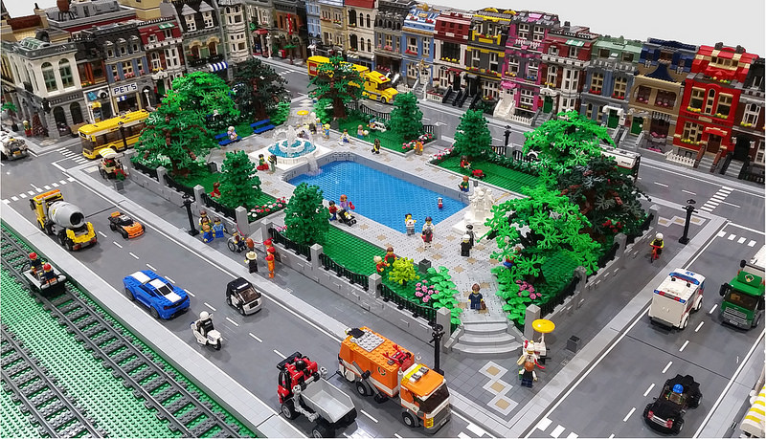

**Lego town (Lego 2017)**

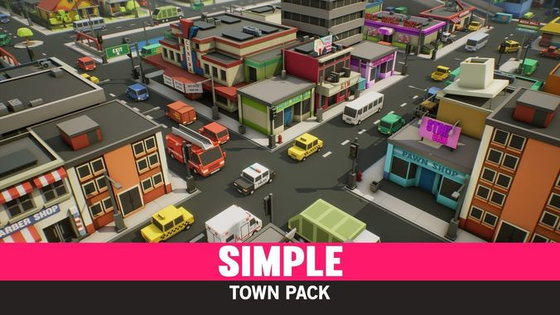A similar idea project of the creation by the 3DMax and Unity

**3Dmax town simulation (3Dmax 2016)**

For the both of audio and visual design of this town pack is fit my prototype assets. This Town pack using low poly to produce each of the model in the scene, that the approaches that I am going to use in the prototype.

# Reference Material

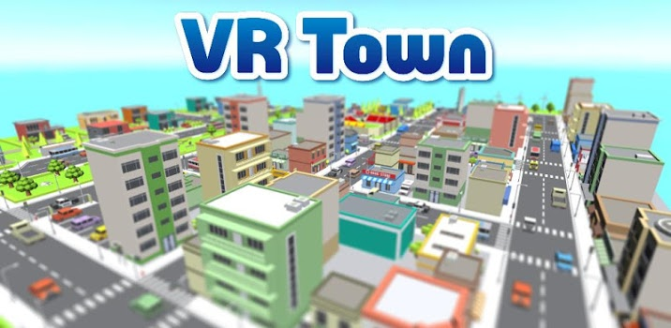The town simulation below is very specifically state out those buildings, car, and trees elements in it. That I would want to recreate in my scene with different looks of these elements. More specifically is to recreate a town with a funny look and with different language names on it.

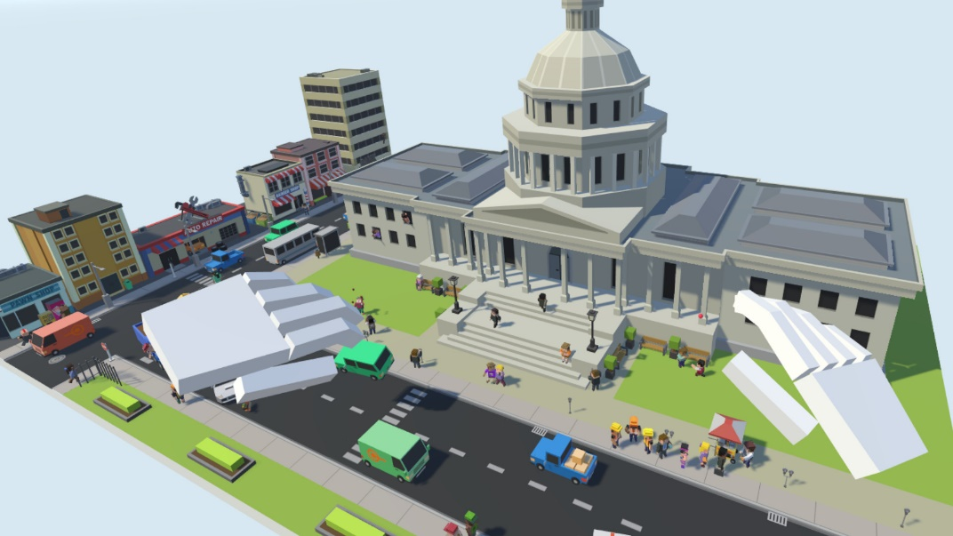The picture below is the look I wanted, with a virtual hand represent the VIVE controllers, which allow user to drag and drop or throwing a color ball onto any objects in the scene.

# Plan for Assets

All the 3D components will mainly create by using 3D MAX and all audio assets will be create by using the audacity software.

For the 3D components that I planned to create which are buildings, characters, cars, trees for the basic components in the scene. Then, I will be creating those street lights, grass, etc. Hence, to demonstrate a town with highly similar in real life. Ideally, for each of those components will have at least 2 different models for each of them. These components are all movable which allows the children to play with it.

For the audio assets, I will mainly be using the audacity software to create those sounds like footsteps, ambient town noises, voices, and car engines for the basic audio. Then, I will be creating those wind, grass, bulb sounds etc. Also, the pronounce voice for each elements or colors in the scene.

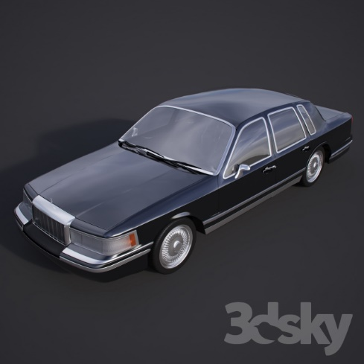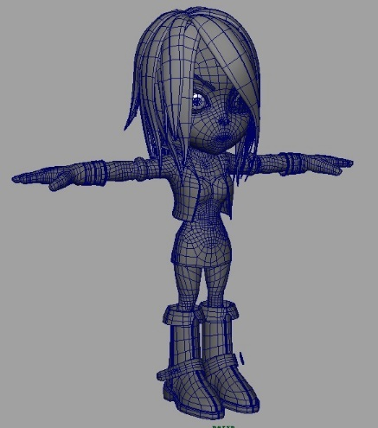For this project, I am intent to use unity to create the scene and applies those functions and meaningful educational elements in it.

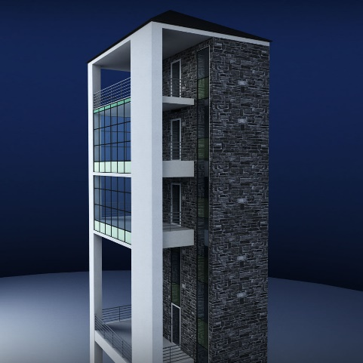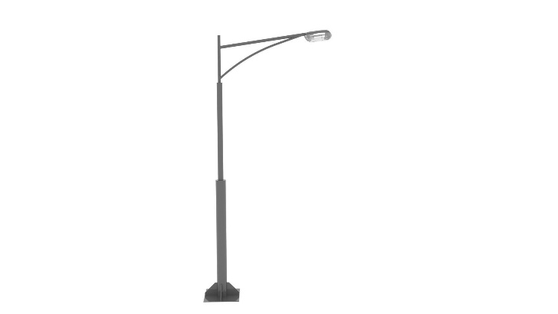 Character(cadnav 2018) Car (andimanche 2015)

Streetlight(3dcadbrowser 2018) Building (Kreatura 2016)

The picture below is the mood board:

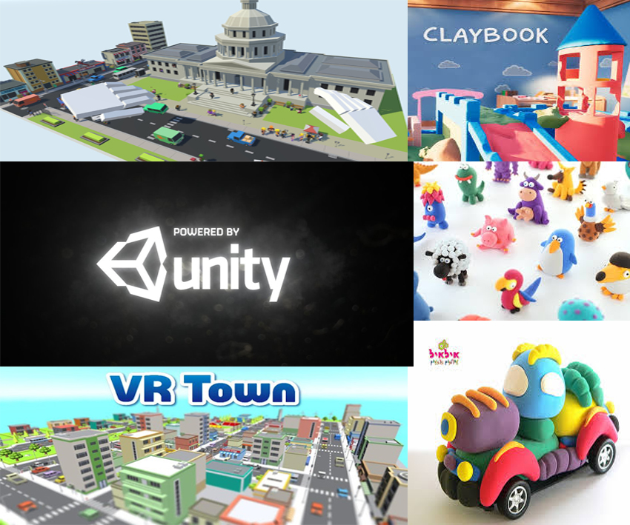

# Third Party Assets

If I can finish the prototype goal before the due date, I could find create some texture that I could applies on each of build and ground at the starting of the scene.

# Conclusion

Overall, I hope that the ditch I proposed above can help children learn while playing. Let this game reach the enjoyable and educational purpose. Although these models are easier to construct than other complex models, it takes a lot of time to study how the model is easy for children to understand and enjoy in it.

# References

1. Kreatura, 2016, Glass tower city building 3D model, cgtrader, retrieved 2 August 2018, <https://www.cgtrader.com/3d-models/exterior/cityscape/glass-tower-city-building >
2. syntystudiossyntystudios, 2016, imple Town - Cartoon Assets VR / AR / low-poly 3D model, cgtrader, retrieved 2 August 2017, <https://www.cgtrader.com/3d-models/exterior/cityscape/simple-town-cartoon-assets >
3. andimanche, 2015, LINCOLN 1990-th TOWNCAR, 3dsky, retrieved 2 August 2018, <https://3dsky.org/3dmodels/show/lincoln_1990_th_towncar >
4. cadnav, 2018, Cartoon girl character 3D Model, cadnav, retrieved 2 August 2018, <http://www.cadnav.com/3d-models/model-23318.html >
5. 3dcadbrowser, T 2018, Poulsen Street Lamp 3D Model, 3dcadbrowser, retrieved 2 August 2018, <https://www.3dcadbrowser.com/download.aspx?3dmodel=19103>
6. mixailtp1mixailtp1, 2016, Element Pact, cgtrader, retrieved 2 August 2018`, <https://www.cgtrader.com/3d-models/architectural/lighting/street-light-4d68c6ac-f4bf-4753-9575-d7152c056dd3 >
7. Magma, 2017, Modular City Park, eurobricks, retrieved 2 August 2018, <https://www.eurobricks.com/forum/index.php?/forums/topic/150216-moc-modular-city-park/ >
8. Takayasu Games, 2018, VR Town Freek, appgrooves, retrieved 2 August 2018, https://appgrooves.com/android/com.TakayasuGames.VRTownFree/vr-town-free/takayasu-games/>
9. cracked-games, 2018, Tiny Town VR, cracked-games, retrieved 2 August 2018, < https://www.cracked-games.org/en/tiny-town-vr/>
10. playstation, 2018, The Drop: New PlayStation Games for 8/28/2018, playstation, retrieved 26 Sept 2018, < <https://blog.us.playstation.com/2018/08/24/the-drop-new-playstation-games-for-8-28-2018/> >
11. Hey Clay, 2017, HEY CLAY® ANIMALS, apkgk, retrieved 26 Sept 2018, <<https://apkgk.com/com.heyclay.CLAY.Animals1> >
12. Adrian,M, 2017, Reading and Generating QR codes with C# in Unity 3D — the easy way, medium, retrieved 26 Sept 2018, < <https://medium.com/@adrian.n/reading-and-generating-qr-codes-with-c-in-unity-3d-the-easy-way-a25e1d85ba51> >
13. Ilil Ziv, 2007, i clay automobile, flickr, retrieved 26 Sept 2018, < <https://www.flickr.com/photos/ililziv/505638116> >